Question A
[20 points; 1000 – 2500 words]

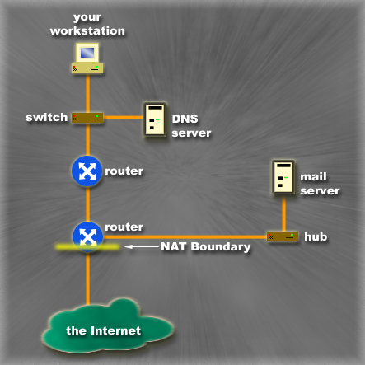

Consider the above network diagram and refer to this diagram when composing your answer to this question. Describe in as much detail as possible what happens after a computer user clicks a web link. The user's computer, shown as the workstation in the diagram below, is connected to an Ethernet LAN and has access to the Internet through the gateway router that connects to a NAT router and then to a backbone service provider (part of the Internet cloud). Explain how the computer establishes an internetwork connection to an Internet web server (within the Internet cloud on the diagram) and retrieves the following (ficticious) resource:
http://www.boringarchives.com:1289/index.html
Your answer to this question should be about 1000 to 2500 words and you will certainly need to include detailed discussion of the following concepts in your writing (in no particular order): (1) Router, (2) Switch, (3) Ethernet, (4) Internet cloud, (5) DNS Server on local LAN, (6) ARP, (7) Proxy ARP, (8) encapsulation, (9) broadcast, (10) unicast, (11) file, (12) segment, (13) packet, (14) frame, (15) bit, (16) signal, (17) frame addressing, (18) frame forwarding, (19) packet addressing, (20) packet forwarding, (21) IP, (22) TCP, (23) sliding window flow control, (24) selective reject error control, (25) three-way handshaking, (26) header fields, (27) CSMA/CD, (28) collision, (29) backoff, (30) time out, (31) soft state, (32) address translation, (33) ANDing process, (34) routing table, (35) client, (36) server, and (37) other concepts as needed. Do not number the concepts in your essay.

Question B
[10 points, 500 – 1000 words]

Describe the design features of IPv6 that have been implemented to solve IPv4 issues. Next provide two rankings of these features: first, a ranking of the features based on the potential improvements to network operations or performance; second, a ranking of features based on the necessity of the solutions. Discuss and draw conclusions about any contrasts within the two rankings. [Within 1,000 words]

